Lesson 9: Exodus 1-4 Moses’ Backstory

Introduction
¹ Now these are the names of the sons of Israel who came to Egypt with Jacob; they came each one with his household: ² Reuben, Simeon, Levi and Judah; ³ Issachar, Zebulun and Benjamin; ⁴ Dan and Naphtali, Gad and Asher. ⁵ All the persons who came from the loins of Jacob were seventy in number, but Joseph was already in Egypt. ⁶ Joseph died, and all his brothers and all that generation. ⁷ But the sons of Israel were fruitful and increased greatly, and multiplied, and became exceedingly mighty, so that the land was filled with them. ⁸ Now a new king arose over Egypt, who did not know Joseph. Exodus 1:1–8
The Book of Exodus. Our kingdom motif consists of six elements: a king, a people, a covenant, a prophet, a land and a palace for the great king. Where do we stand now at the beginning of Exodus? God intends to establish for himself a kingdom of priests, a holy nation. Yet, we seem to have gone backward rather than forward. The sons of Israel came to Egypt, guests of Pharaoh on behalf of Joseph. But that Pharaoh is long dead. The current Pharaoh knows nothing of Joseph. He has enslaved the Hebrews, fearing their number. And he has commanded, “Every son who is born you are to cast into the Nile (Exodus 1:22).”
After 400 years in Egypt, according to the prophecy given to Abraham, we have a people, though they are slaves to their Egyptian masters. We have no free nation, no covenant law for that nation, no land, no temple, and the people may feel like they have no God. Where is God? I titled Genesis “Kingdom Prologue.” There the Israelites’ relationship to God was defined. We know who they are. We know how they got to Egypt. We have come to know a lot about their relationship to God who is both covenant King as the one who reigns over all mankind, and also covenant King in special relationship initiated through the promise made to Abraham. And we know that they struggle to be faithful in that covenant relationship.
Exodus: Kingdom Establishment
Key Passages: 19:6; 34:6-7
Chapters 1-18  God redeems the nation | Chapters 19-24  God cuts a covenant | Chapters 25-40  God indwells the tabernacle
King, mediator, people | Covenant | Palace
Israel has now grown way beyond the size of one family. We have a people. God is going to formally establish Israel as a nation by freeing them from Egypt and giving them a defining covenant of law. I have titled Exodus “Kingdom Established.” That is what God is going to do here. Establish for himself a kingdom. We can take Exodus in a simple three-part division. God redeems a people in chapters 1-18. God cuts covenant to form a nation in 19-24. And God indwells the tabernacle in 25-40.
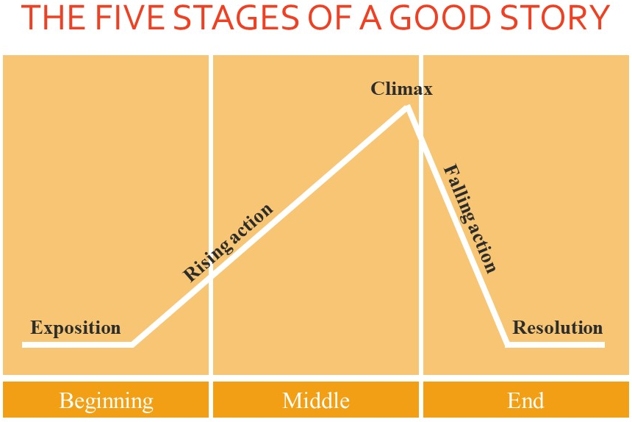
That is the broad stroke outline we will use. Its also helpful to think about Exodus as a great narrative. The historic reality of what God did, redeeming Israel out of Egypt is amazing, and Moses did a fantastic job telling that story. The Greeks argued that every good story has a beginning, a middle and an end. And that includes five stages: exposition, rising action, climax, falling action, and resolution. Exposition gives us the background. So, in a super hero tale, this is the origin story, the teenage kid gets bit by a radioactive spider. In our rising action the super hero tries out his powers, meets a girl, encounters a villain, considers giving it all up, but the villain takes the girl. And now the stage is set for the climax. On one side of the bridge dangles the sweetheart, on the other side of the bridge a bus full of children, and the villain hovers above. How does our super hero get out of this? In ancient Greece, comedy means the hero wins and saves the day. Tragedy means everybody dies. So, what is going to happen? Whatever happens, once we are past the conflict, whether it is tragic or comedic, we move into falling action. Will they get married or will he give her up to save her from danger, resigned to fight crime alone? Resolution wraps up the story. It would be the wedding or the lonely webslinger swinging off into a New York sunset.
That is the structure of a good story. And I don’t know if Moses was following that structure, but it really helps to think about Exodus as a well, crafted narrative. So, let’s think about it in that way. Let’s start with the climax. What would you say is the climatic moment of Exodus, the moment where all the tension builds to this supreme event? What’s the climax? There are a few options that might come to mind. People usually think about the end of slavery in Egypt, so the Red Sea really stands out. God decisively demolished the army of a superpower to secure the freedom of his people. The Egyptian military is wiped out under the waves as the people of Israel watch safely on the far bank. So, the Red Sea is a good choice. The Red Sea ought to be our climax. The rest should be falling action, a song of deliverance, the journey to Sinai, the cutting of covenant, and the building of the tabernacle in which God’s glory comes to dwell in our final scene of resolution. It is not that the falling action is unimportant. It is just that the tension has been passed. And we are simply working out the rest of the plan, the rest of the story.
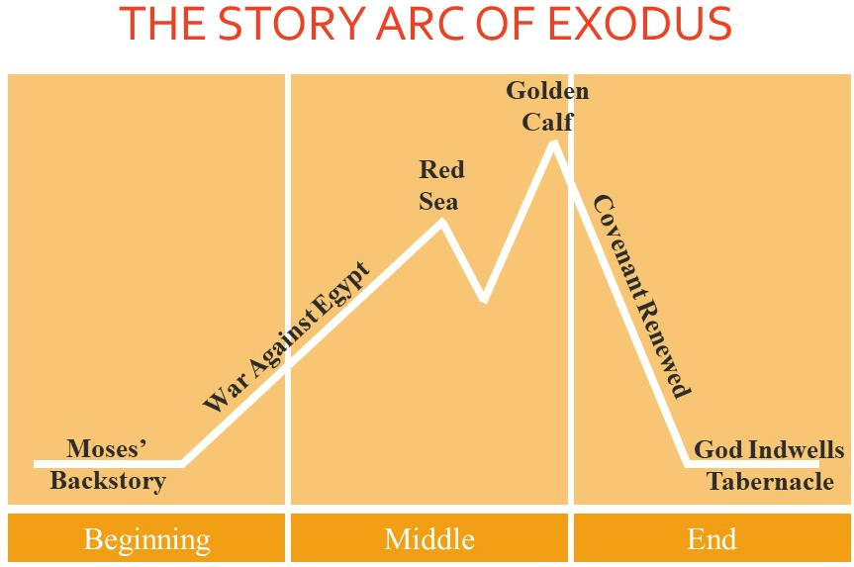
But that is not how the story goes. It does not all just nicely work out after the Red Sea. There is a major twist. The Red Sea is the false climax. It is a climatic event, but it is not the real problem of the story. There is a twist that reveals this theological truth. It is one thing to get Israel out of Egypt. It is another thing entirely to get Egypt out of Israel. The true climax of Exodus comes after covenant has been cut on Mt. Sinai. And Moses has gone back up on the mountain. And the Israelites make a golden calf to worship. It had appeared that the enemy of Israel was external, the Egyptians. That’s our problem. Our problem is outside of us. But now we see that an insidious enemy resides within the heart of every member of that people. Really in the heart of every man and every woman. Rebellion dwells within. So, wherever we go, our sinful nature invites destruction from a holy God. That is the climax that must be resolved. What will God do with such a people? How does he avoid tragedy, where everybody dies?
According to the five stages of a good story, we start with exposition, so chapters 1-4, the backstory of Moses. Then we have rising action in chapters 5-31 from the time Moses sets off for Egypt to the covenant cut on Mt. Sinai. The climax comes in chapter 32 with the golden calf. And what follows that incident, that is our falling action. And it leads to resolution which comes in the final paragraph.
So, in this lesson we are just going to cover exposition or backstory. I am going to address that backstory in three parts. So, this will be chapters 1-4. First, the origin story, that’s chapters 1-2. Then the call of Moses, 3:1-4:17. And finally the setting out of Moses in 4:18-31.
We start with the origin story.

I. Origin Story (1-2)
Chapter 1 explains to us briefly, but believably, how the status of the Israelites shifted from favored friends to slaves. They had settled in Egypt by the goodwill of a former Pharaoh. The text says, “they were fruitful and increased greatly, and multiplied and became exceedingly mighty [or numerous], so that the land was filled with them.” The promise God made to Abraham was coming to bear. His descendants were fruitful like stars in the sky, too fruitful for the Egyptians.
Egyptologists tell us that the 14th through 17th dynasties of Egypt struggled with or were ruled by a foreign mix of peoples called the Hyksos. That was from about 1700 BC to 1540 BC. After that the native Egyptians re-established control. And looking into the Bible, the earlier date of the Exodus proposed by biblical scholars is 1446 BC. That comes from 1 Kings 6:1 which tells us that the 4th year of the reign of Solomon was the 480th year anniversary of the Exodus. So, we can date that back to 1446 BC. So, taking that date of the Exodus, places the life of Moses just after the Hyksos period. Egypt had just come out of foreign domination by the Hyksos. So, Egyptian fear of a massive Semitic nation in their midst makes a lot of sense with that biblical dating.
This Pharaoh goes about suppressing the potential Hebrew threat in a particularly nasty way, enslaving the nation and ordering baby Hebrew boys to be thrown into the Nile river. That’s what Moses’ mother does, though she does it rather gently. She places him into the river in a basket. Moses is found by a princess of Egypt and raised in Pharaoh’s household, though in the beginning nursed by his own mother.
So, we have to imagine what growing up was like for Moses. The text skips ahead to a grown Moses, telling us in 2:11 that he “went out to his brethren and looked on their hard labors; and he saw an Egyptian beating a Hebrew.” Moses then killed that Egyptian and hid his body. Later, Moses tried to break up two Hebrews fighting, but they retorted, “Who made you a prince or a judge over us (2:14)?”
I see a couple of things in this story. First, Moses shows classic signs of a third culture kid. He is neither fully accepted as Egyptian nor fully accepted as Hebrew. He does not seem to be sure of his own identity. The text said that he went out to his brethren, suggesting he does consider himself in some way a Hebrew. But he does not live with them and probably does not dress like them. So, the two Hebrews look at him and ask, “Who made you are prince or a judge over us?” “You dress like a wealthy Egyptian, but you have no authority over us. You are not one of our leaders.” We don’t accept you.
The second thing that stands out is a foreshadowing of what is to come. Moses sees himself in some way as a protector or savior of the Hebrews. He is moved by their plight. And so, he strikes out rashly without wisdom. Maybe he had fantasies in his head, connected to his own search for identity as a Hebrew, that he was in the house of Pharaoh for this reason, to be the liberator of his people. You can imagine him creating this story in his mind that makes sense of childhood. But that fantasy comes crashing down. Now he is only afraid. And rightly so. Pharaoh may have tolerated his daughter’s whim of raising up a Hebrew brat, but Pharaoh will not tolerate a Hebrew killing an Egyptian. He decides to kill Moses. So, Moses flees to Midian, where he sits down by a well.
And what happens? He finds a wife of course; lovely places, those ancient near eastern wells. They were like dance clubs or college Christians organizations. Moses marries Zipporah, has a son, and settles down to the life of a shepherd. He lives this life for forty years. The dream of liberating Israel was put aside long ago as immature fantasy. He has a new identity, a new home, a new purpose. And then we read about the cries of Israel. 2:24 says, “God heard their groaning; and God remembered His covenant with Abraham, Isaac, and Jacob.” That’s the same verb used at the height of the flood. “God remembered Noah.” Just like then, this remembering here does not mean that God got busy and forgot about the Israelites for 400 years. Where does the time go? This remembering is a covenantal remembering. God never forgot. The remembering emphasizes the saving action of God. Now is the time he has chosen to act. God remembers.
This is the origin story of Moses. 40 years in Pharaoh’s household. 40 years as a Midianite shepherd. That’s a long origin story? But now God is ready to act. So, why did God wait so long? Why didn’t God use Moses when he was younger, when he had the vision and the vigor to act as a deliverer? I am sure God had all kinds of reasons for the timing. One thing we see is God’s sovereign preparation of the person he plans to use.
It is fascinating to think about what kind of person Moses had become. First, Moses had to learn humility. He had to give up his grand visions. God gave him great opportunity to be humbled. If you want to be humbled, get married, have a child, live as a foreigner in a culture not your own, learn a job you have never performed. Moses had great opportunity to learn humility. And there is more. How did Moses’ experiences prepare him for the task God would call him to? He would lead Israel from Egypt to the Promised Land, and he would write the Torah. This is his task. How did the first 80 years of life prepare Moses for that?
Well, he is being told to go to Pharaoh. And Moses was acquainted with the house of Egypt. He had grown up there. He was familiar with the halls of Egyptian power. He could have been taught there the literature of his day. Thinking about writing the Torah, Moses was one who was familiar, potentially, with narrative, and law, and royal records, and poetry, written by Egyptians and Hittites and Babylonians. He was likely tri-lingual, learning Hebrew from his mother, Egyptian from his foster mother, and Midianite from his wife. Taking the Israelites from Egypt to the wilderness, he would be taking them where he had led sheep for 40 years. He knew the geography. He knew where to find food and water. He knew how to live out there. He had learned to lead sheep. Moses has this strange blend of one at home in the halls of Egypt, identified with Hebrew slaves, and comfortable roaming the wilderness as any Midianite shepherd. Moses’ whole life had been preparation in character, knowledge, and skills which God now intends to put to use.
That is the origin story of Moses. The text next turns to the call of Moses.

II. Moses’ Call (3:1-4:23)
Out in the wilderness, God appears to Moses through a burning bush. It is a holy place, a holy meeting. Why a burning bush? Here is the text. It seems important in the text. “And the angel of the LORD appeared to him in a blazing fire from the midst of a bush; and he looked, and behold, the bush was burning with fire, yet the bush was not consumed (Exodus 3:2).” In verse 3 Moses emphasizes the strangeness of what he sees, “I must turn aside now, and see this marvelous sight, why the bush is not burned up (3:3).”
We might conclude that the bush is not burned up simply because it was meant to be a miracle to attract Moses’ attention. God is just trying to get him to come over. I think there is more to it, a lot more. I think the bush symbolizes the main theological point of the book of Exodus. I think Moses is suggesting to us the question we should be asking, “Why is the bush not burned up?” What does that symbolize? Why is that important? I am going to leave that question for you to reflect on. You think about that as we are going through the book of Exodus. What is the symbolism of the burning bush? It is more than just the presence of God. It is more than that. It symbolizes a theological truth. And I promise I will come back to that before we finish the book Exodus. But you think on it.
Here is the message from the bush. This is what God declares to Moses in verse 8, “I have come down to deliver my people from the power of the Egyptians and to bring them up from that land to a good and spacious land.” Moses hears the words of God and fears. He fears God speaking, which is a right response if you hear the voice of God. He may also hear and be glad. Glad can join in that holy fear, the gladness that God is going to deliver Israel. But he has not heard the whole plan, yet. And he is not going to be excited when he does. Let’s read the plan. This is what God says next. This is 3:10-15.
¹⁰ “Therefore, come now, and I will send you to Pharaoh, so that you may bring My people, the sons of Israel, out of Egypt.” ¹¹ But Moses said to God, “Who am I, that I should go to Pharaoh, and that I should bring the sons of Israel out of Egypt?” ¹² And He said, “Certainly I will be with you, and this shall be the sign to you that it is I who have sent you: when you have brought the people out of Egypt, you shall worship God at this mountain.” ¹³ Then Moses said to God, “Behold, I am going to the sons of Israel, and I will say to them, ‘The God of your fathers has sent me to you.’ Now they may say to me, ‘What is His name?’ What shall I say to them?” ¹⁴ God said to Moses, “I AM WHO I AM”; and He said, “Thus you shall say to the sons of Israel, ‘I AM has sent me to you.’ ” ¹⁵ God, furthermore, said to Moses, “Thus you shall say to the sons of Israel, ‘The Lord, the God of your fathers, the God of Abraham, the God of Isaac, and the God of Jacob, has sent me to you.’ This is My name forever, and this is My memorial-name to all generations.

1. Moses’ first refusal and the name of God (3:10-22)
This is the shocker for Moses, “I will send you to Pharaoh.” The plan is not just about God’s act of deliverance. The plan is to include Moses. God involves his people in his works of salvation. And upon hearing he is to be involved, Moses then asks the wrong question. It is the natural question. It is the question we often feel when we realize that God wants us to do something that we can’t do, and we don’t want to do. Moses asks, “Who am I that I should go to Pharaoh and that I should bring the sons of Israel out of Egypt?” He is thinking, “I don’t have the power to do this. I don’t have the credibility to do this. I don’t know what I would say or do. I don’t even know how to get started. Why would Pharaoh give me an audience? Who am I to do this thing? What if I mess it up? What if I say the wrong thing? What if I make the wrong choices? I am just a shepherd. Who am I?”
God responds, “I will be with you.” It is the same thing Jesus told his disciples after giving them the great commission in Matthew 28:18-20, “And lo, I am with you always, even to the end of the age.” Moses follows up with the right question. He asks God what to tell the Israelites when they ask who sent him. He asks what name to give them. That is the right question to ask when God tells us to do something, not “Who am I?” but “Who are you?” Who you are is secondary. Who the God is who is calling you that is the key question.
And God says, tell them “I Am Who I Am.” This is the name, Yahweh. In the Hebrew it could mean “I was who I was,” “I am who I am,” “I will be who I will be.” God is the God who was, and is, and is to come. He is the same yesterday, today, and forever. God is. He exists independently of any created thing. He is completely whole. He is completely able. He is complete. He is the God who is. I am. Yahweh is the name Genesis 2 uses when he breathes life into Adam. By the name Yahweh, he promised Noah in Genesis 8:21 to never again destroy the earth by water. By the name Yahweh, he called Abraham in Genesis 12:1, and he cut covenant with him in Genesis 15. By this name he renewed covenant with Isaac in Genesis 26 and with Jacob in Genesis 28. Yahweh is the one who makes covenant. He is the God who is, and the God who invites people into relationship with him. He is both transcendent, and he is immanent. Who are you to proclaim the news that God has come to save? You are the servant of Yahweh, that’s who you are.

2. Moses’ second refusal and miraculous signs (4:1-9)
Moses is not yet convinced. In 4:1 he asks, “What if they will not believe me, or listen to what I say? For they may say, ‘The Lord has not appeared to you.’” That’s a fair question. Moses will be asking them to stake their lives on his leadership. So, God empowers Moses to miraculously change his staff to a snake and to cause leprosy. Moses sees these miracles himself, which ironically show us the weakness of miracles to cause true belief in the heart of a man. Because even after having performed the miracles himself, Moses is still unchanged in heart. He still does not want to go. And he gives a third excuse. This is 4:10-12.

3. Moses’ third refusal and the gift of speech (4:10-12)
¹⁰ Then Moses said to the Lord, “Please, Lord, I have never been eloquent, neither recently nor in time past, nor since You have spoken to Your servant; for I am slow of speech and slow of tongue.” ¹¹ The Lord said to him, “Who has made man’s mouth? Or who makes him mute or deaf, or seeing or blind? Is it not I, the Lord? ¹² “Now then go, and I, even I, will be with your mouth, and teach you what you are to say.”
It makes you wonder why God continued patiently with Moses after this excuse. Moses points out that he has never been eloquent, “In case you have not noticed, God.” And he adds to this, “neither recently nor in time past, [and catch this] nor since you have spoken to your servant.” “Nor since you have spoken to your servant.” “I have never been a good speaker Lord. In my youth I was a man of action and that did not work out the best. Since then, I have worked with sheep. Not much eloquence is required with sheep. I have never been good with words, and if you have not noticed God that has not changed in the short amount of time you have been speaking with me.”
Woah. It takes some kind of courage to say that to God. We should maybe pick up some frustration in God’s tone, even though he is still being patient with Moses. And he says, “Who has made man’s mouth?” And he says again I will be with you. “I will be with your mouth.” “I will give you the gift of speech. I will guide you in what to say.” Again, it is not about your skillfulness Moses. That is not why I chose you. And that should be enough. Moses has learned humility and that is good. But he has swung from self-confidence to serious self-doubt. He is certainly not over-confident anymore. But godly humility is not the same thing as self-recrimination. “I am not good. I have nothing to offer. I can’t do this.” With godly humility you look at yourself with sober acknowledgement of who you are not and also who God has made you to be. Godly humility takes that sober reflection of self and adds faith to it. “I have a lot of weaknesses Lord. There are strengths, too, a lot of weaknesses. I cannot do this thing you are asking. But you can. You would not be telling me to do it, if you did not have a plan. I am scared. I do not see how it is going to work out. But I will give you all I have got. I will trust you. You are the deliverer. And I am with you.”
That’s the godly humility Moses will get to. It is a humility not frozen by self-deprecation or by fear of failure. Moses will get there, but he is not there yet. So, he refuses a fourth time in 4:13.

4. Moses’ fourth refusal and God’s burning anger (4:13-17)
But he said, “Please, Lord, now send the message by whomever You will.” “Whomever you will!” I mean really. That’s not what Moses means. He means, “Whoever you will besides me,” because God obviously wills that it be Moses. And finally, God is done being patient. Verse 14, “Then the anger of the Lord burned against Moses…”
God’s anger burns, but he does not even now give up on Moses. He tells him that Aaron who speaks fluently will partner with him. And I am not sure that God is a case of God giving in to Moses. God may have planned all along for Aaron to participate. He just first gave Moses the opportunity to trust, and then he was going to surprise him, saying, “Hey, and guess what? I am also sending Aaron with you.” We do not know what the plan would have been. Moses just could not get there by faith on his own. Sometimes our faith needs a push. We need a little heat to get us going in the right direction. So, God allowed his anger to burn. And that got Moses up off his seat. Moses acquiesces. He returns to Midian and asks his father-in-law Jethro, “Please let me go, that I may return to my brethren in Egypt.”
So, we come to our third section. We have seen the origin story. We have considered the call of Moses. Now we have got Moses setting out in 4:18-31.

III. Moses Sets Out (4:18-31)
And this brings us to a transitional moment in our whole narrative. Moses creates the transition in the narrative by giving us three different scenes. The first is going to be in Midian, then one on the way to Egypt, and then one in Egypt.

1. Death of the first-born (4:18-23)
So, while still in Midian God tells Moses how things are going to turn out in Egypt. This is 4:21-23.
²¹ The Lord said to Moses, “When you go back to Egypt see that you perform before Pharaoh all the wonders which I have put in your power; but I will harden his heart so that he will not let the people go. ²² Then you shall say to Pharaoh, ‘Thus says the Lord, “Israel is My son, My firstborn. ²³ So I said to you, ‘Let My son go that he may serve Me’; but you have refused to let him go. Behold, I will kill your son, your firstborn.” ’ ”
By this promise we are prepared for what is coming. God tells us that he intends to follow through with all 10 plagues. He will even harden Pharaoh’s heart to get there. He also tells us why. God considers Israel his firstborn. Pharaoh has been throwing baby Israelites into the Nile river. Just as God saved one of those babies out, now he will save the rest of the nation out. And he is going to bring punishment on Egypt in the same kind as Egypt used to terrorized Israel. And we will take some time to think about God’s sovereignty and justice in our next lesson. For now, Moses sobers us, revealing to us the seriousness of God in his anger at Egypt.

2. Protection in covenant (4:24-26)
This next story in verses 24-26 is sometimes called a seam in the narrative. I think that can be helpful term for us, though I want to distance myself from what documentary hypothesis scholars mean when they use it. I explained in my last lesson on ancient near eastern backgrounds that many scholars hold to the documentary hypothesis as a theory that these books of the Bible came from several different sources which were much later stitched together by a final editor. And this stitching together has left seams in the narrative. According to them, when we see and odd story that does not seem to fit, we can explain that oddity by assuming this is just what happens when an editor stitches together related stories by different authors.
That is the last thing I want to encourage you to do. It so misses the point. Quite the contrary, like with the story of Judah in the middle of the Joseph narrative, when we encounter something that seems to not fit, our minds should perk up and take notice. We should really start to think about those things. Because it is usually intentional by the author. So, rather than discounting the scene as foreign to the narrative, we should be asking, “Why did the author put this here?” He wants us to stop and pay attention. So that’s what we should do with Exodus 4:24-26, is stop and think about what is going on.
²⁴ Now it came about at the lodging place on the way that the Lord met him and sought to put him to death. ²⁵ Then Zipporah took a flint and cut off her son’s foreskin and threw it at Moses’ feet, and she said, “You are indeed a bridegroom of blood to me.” ²⁶ So He let him alone. At that time she said, “You are a bridegroom of blood”—because of the circumcision.
The debatable question with this passage is who the Lord is seeking to put to death. The Hebrew text reads, “sought to put him to death.” So, if your Bible identifies the “him” as either Moses or the son of Moses, then it is helping you out with interpretation. They are both valid options, according to the grammar. But we are the ones who are left to decide which one is. Because we just have the pronoun him. So, is it Moses or is it his son? I am going to let you think about that. And I encourage you to consider what comes right before this and what comes right after this. What action does Zipporah take? What does that say about her? About Moses? About God?
That’s why this text is here. It is to make us think. And so, I do like calling it a seam, not because it indicates the stitching together of the narrative by different authors but by the original author. He is bringing some things together. And this is a transition that is going to move us along. God has just declared the seriousness of his judgment on Egypt and with this story that seriousness becomes personal. The seriousness of God enters into the home of Moses. I think this is about the integrity of the leader. And after this we are going to continue on with our transitional journey to Egypt.

3. Initial reception by the Israelites (4:27-31)
So, Moses first meets Aaron at Mt. Sinai. I would love to hear more of that story. But we will have to ask Aaron when we meet him because the text does not tell us. It just tells us the brothers journey together back to Egypt and present God’s plan to the elders, with Aaron speaking and Moses performing the miracles. And then we conclude with verse 31, “So the people believed; and when they heard that the Lord was concerned about the sons of Israel and that He had seen their affliction, then they bowed low and worshiped.”
Moses had cause to rejoice. God had promised deliverance and the people have received that promise, and they have received Aaron and Moses as the spokesmen of God. Things are working. We are learning to be cautious, however, when the text says that people believe. We do not want to give too much or too little credence to that belief. Something is going on here. But it is about to be sorely tested. And the stories of Genesis have set us up to recognize that belief in the reality of God is not the same thing as the belief that submits in trust to the will of God. We have also come to see that even when a person has the later kind of belief, the kind that trusts and submits to the will of God, that belief is not the same thing as spiritual maturity. Faith that does not waver may still have a lot of room to grow. So, which kind of belief are these Israelites expressing and what kind of process is necessary to cause that belief to grow? We are going to have to wait and see where the story goes from here.

Conclusion
Few people in history will play a role in the kind of momentous events that Moses is about to enter into. This is the stuff of legend. And I do not mean unreal legend. I mean more than just real. It is the real kind of event that defines moments in human history. And because of how momentous this all is, it really is fantastic that we get such a personal, human view of Moses. His response to God at the moment of his call is so authentically real. We should not think, “I am no Moses. How could I ever learn from his story or compare myself to Moses?” To say that would be humorously ironic, because in saying those words you would be sounding very much like Moses. “Who am I? Who am I to do this?” That is exactly what he said. It is what we say. See, you are like Moses. And you can learn from him. You can model yourself after him.
So, let’s consider these three questions inspired from his call. I am going to leave you with this. So, get in quiet place some time, now would be good, if you are already in a quiet place, or later, and ask God these three questions.
First, “God, what are you calling me to do? What are you calling me to do as a Christian that you call all your children to do? And what are you calling me to do as an individual, with my own personality and my set of relationships? What are you calling me to do?”
Second, “How are you preparing me God? What experiences and skills and gifts have you given me that can be used in your service? Help me consider myself soberly before you, acknowledging my strengths and my weaknesses? Help me recognize your ongoing work to develop me. Is my character where it needs to be? Am I humble? Do I have integrity? Please God, mold me. How are you preparing me God?”
Third, “Who are you God? Am I trusting too much in who I am? Am I fearful that I am not good enough? Is my focus primarily on me? Help me to grow in my knowledge of you? Help me believe that you are always with me and that that is the most important thing of all. Who are you God? Show me and help me to believe.” What are you calling me to do? How are you preparing me? And who are you, who calls me and is with me?

Reflection Questions
1. What stands out to you as you look over the backstory in Genesis 1-2? Do you think that Moses’ rash action in killing the Egyptian taskmaster was somehow motivated by who God was calling Moses to be? What stands out to you in the way God prepared Moses for his future calling?
2. What stands out to you as interesting or important or strange in Genesis 3-4 with the call of Moses?
3. How does the seam in Genesis 4:24-26 contribute to the transition from the call of Moses to the beginning of action in Egypt? Who do you think God sought to kill in 4:24? Why? What do you learn here about God, Moses and Zipporah?
4. What theological theme or truth might the burning bush be meant to symbolize? Any ideas?
5. Take some quiet time to reflect on the three questions inspired by the call of Moses. (a) What are you calling me to do God? (b) How have you prepared me God? (c) Who are you that calls me God?

